**EXPERIMENT : 3**

**COLLEGE ADMISSION SYSTEM**

Use Case Diagram

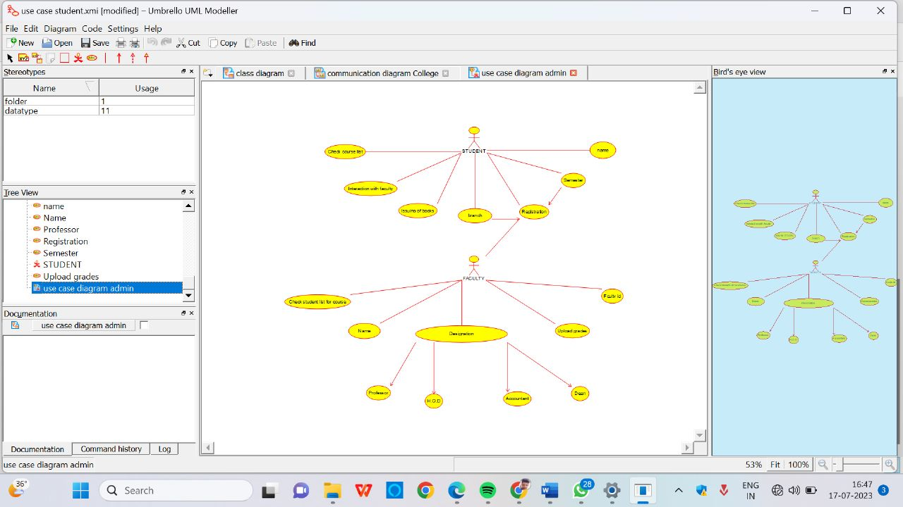

Sequence Diagram

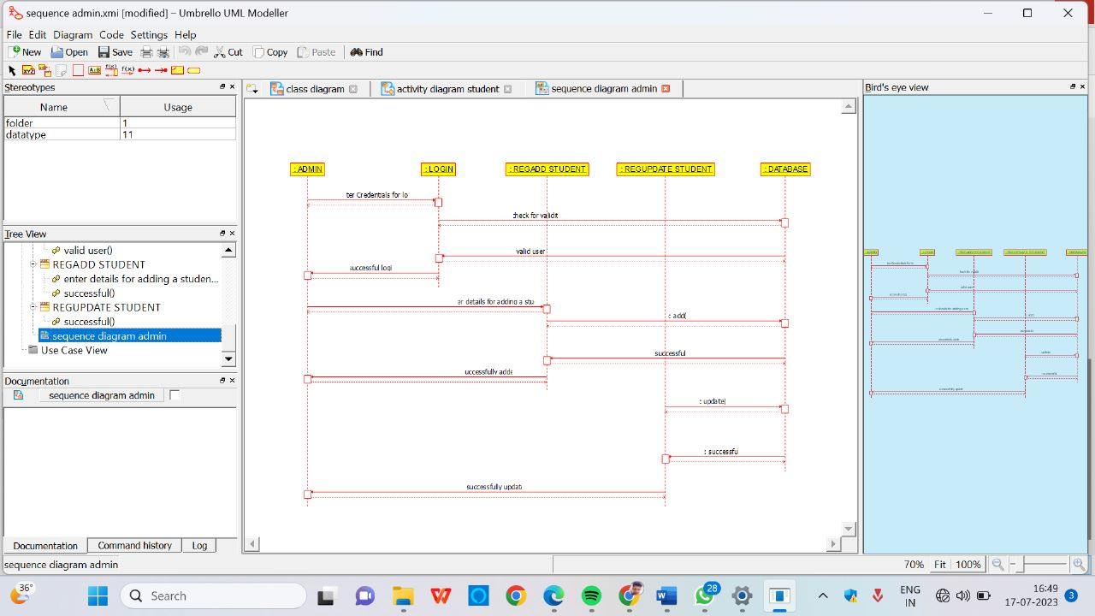

Class Diagram

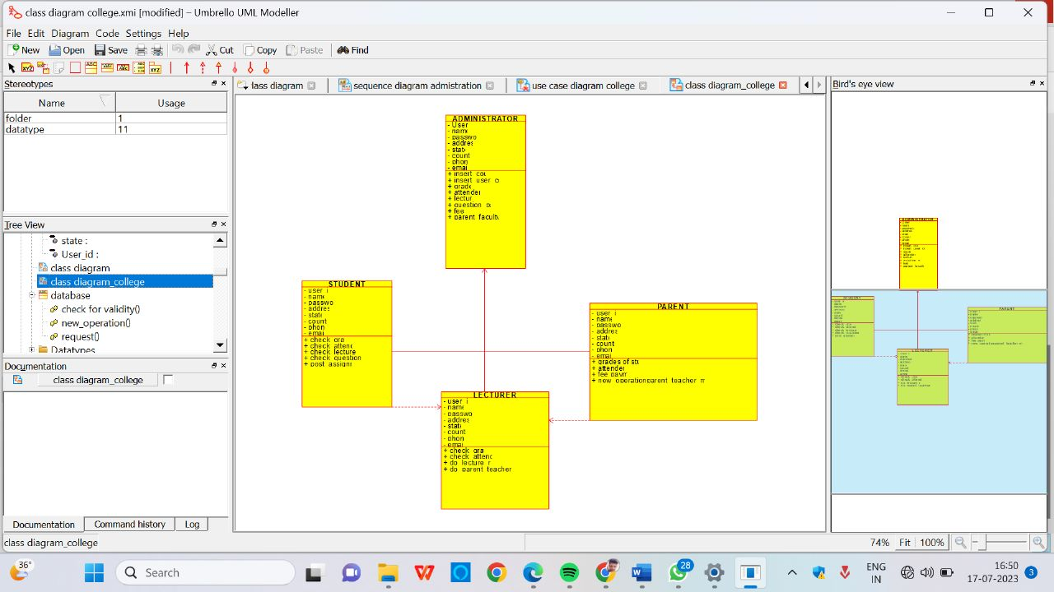

Use case Diagram student

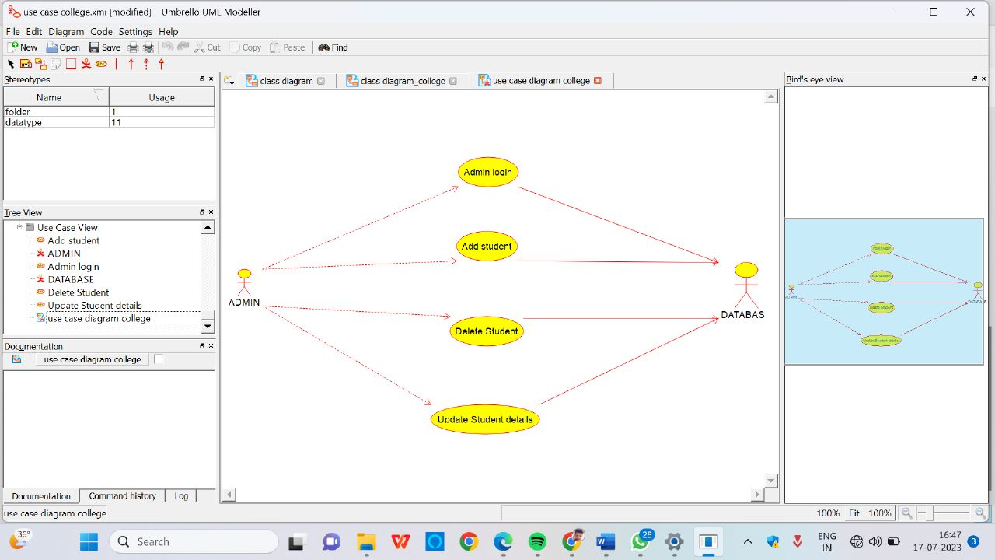

Collabaration Diagram

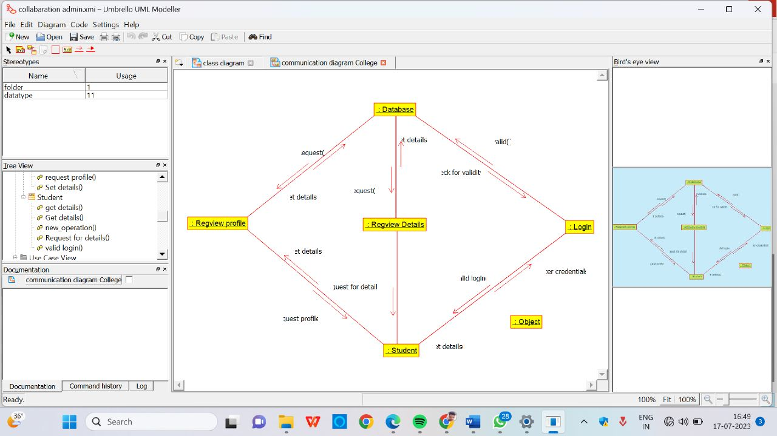

Collabaration Diagram College

